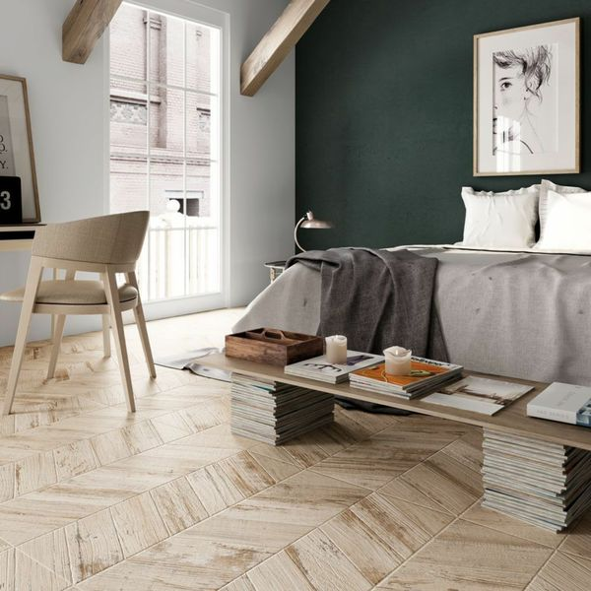**Caramel Varnish Chevron Wood Tiles:**

## **Product Description**

Create a striking statement floor or feature wall in your home this season with the introduction of these Caramel Varnished Chevron Wood Tiles. They have an eye-catching chevron layout. Made from porcelain, these wood effect tiles have an aged, faded painted effect; ideal for injecting character into a kitchen, bathroom or living area floor or wall space. They have a matt finish. Want to get the full effect? Order a sample.

## **Product Info**

* Product ID: 15658
* Tiles Per SQM: 2.4691358024691
* Sale by: Per SQM
* Size: 450x900x9mm
* Weight: 9.98 KG
* Material Type: Porcelain
* Finish: Matt
* Colour: Beige/Ivory, Brown
* Suitability: Floors, Walls
* Grade: 4
* Rectified Edge: No
* Underfloor Heating: Yes
* Thickness (mm): 9